**MIDDLETON CHENEY FOOTBALL CLUB**

**ANNUAL GENERAL MEETING**

**1979**

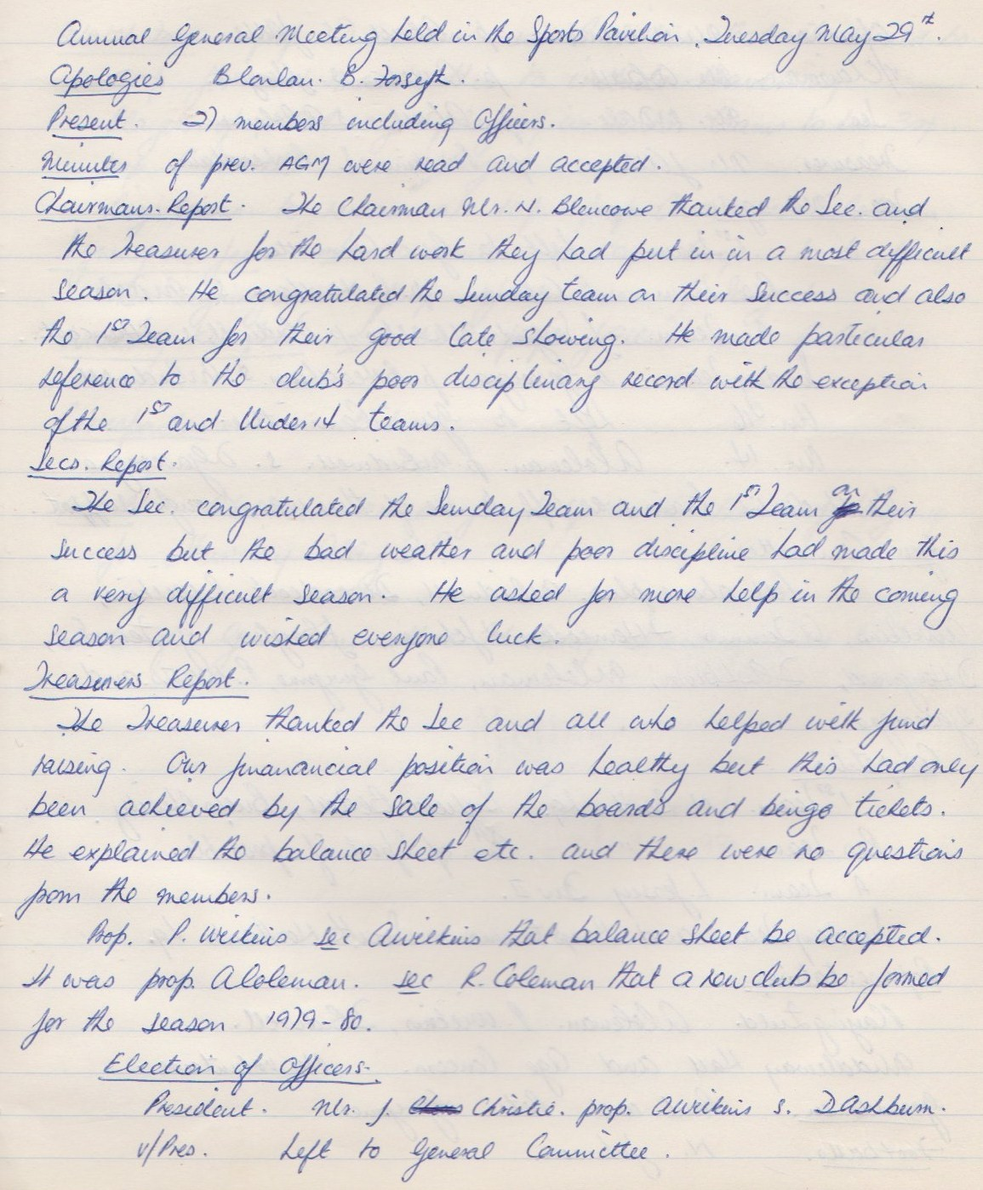

**Continued**

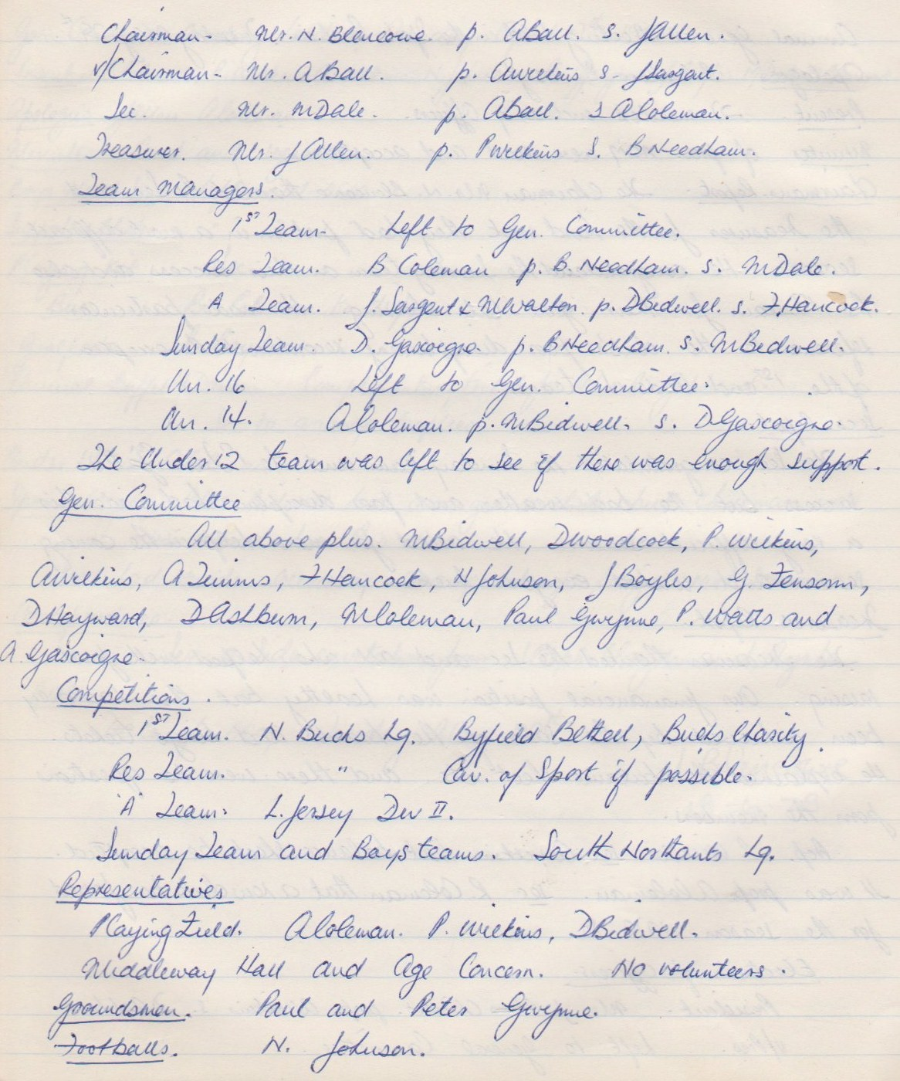

**Continued**

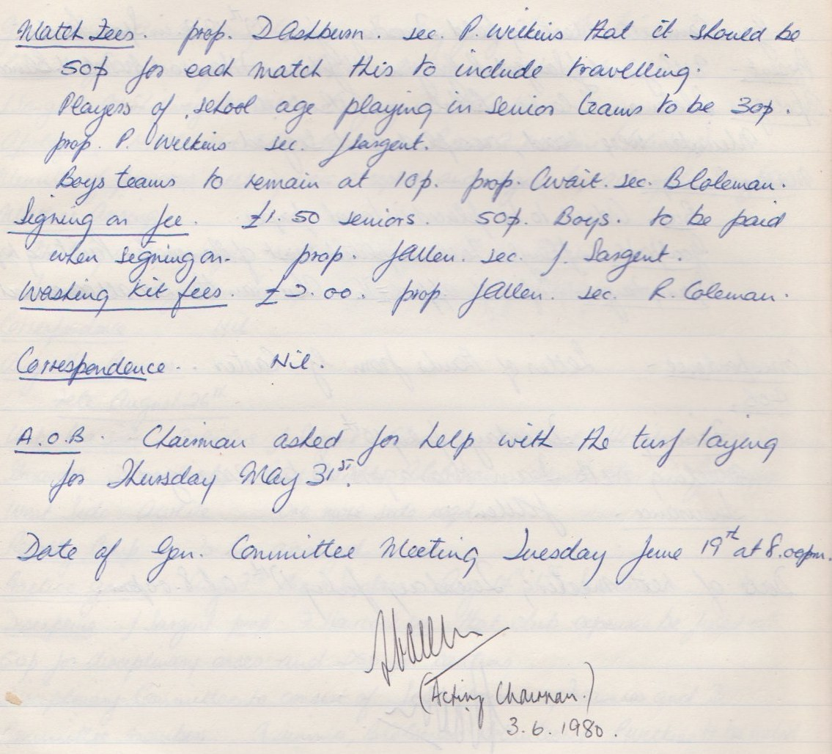

**General Committee Meeting**

**June 19th 1979**

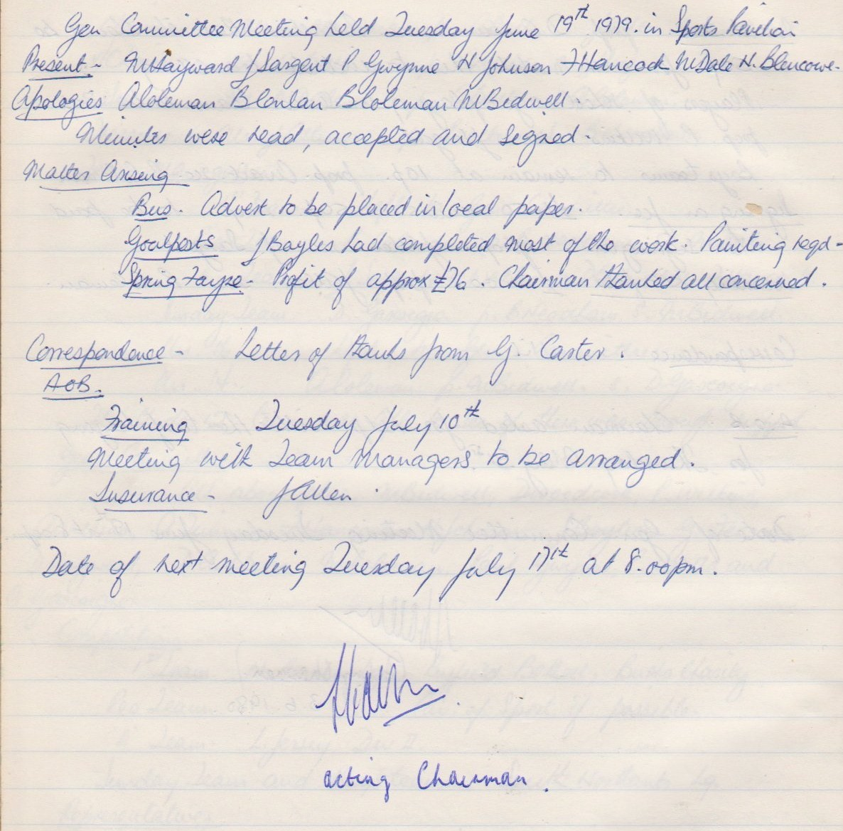

**General Committee Meeting**

**July 17th 1979**

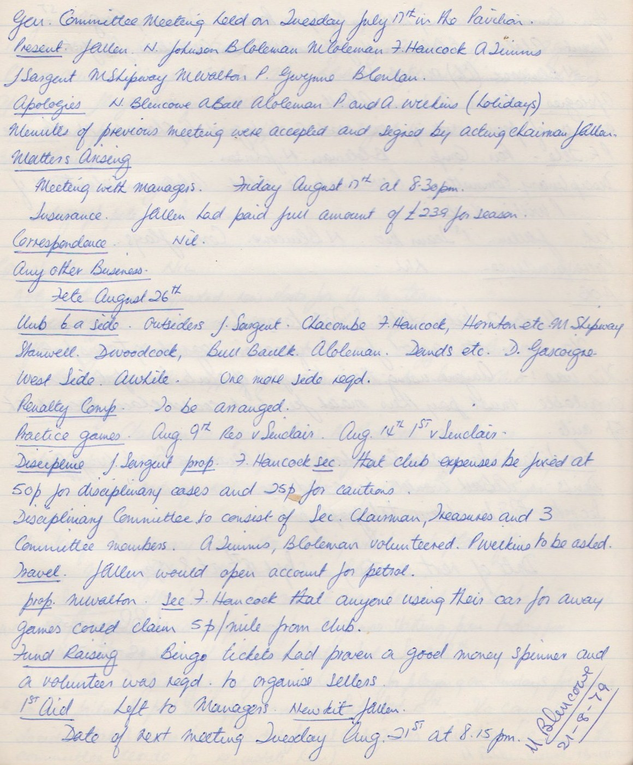

**General Committee Meeting**

**August 21st 1979**

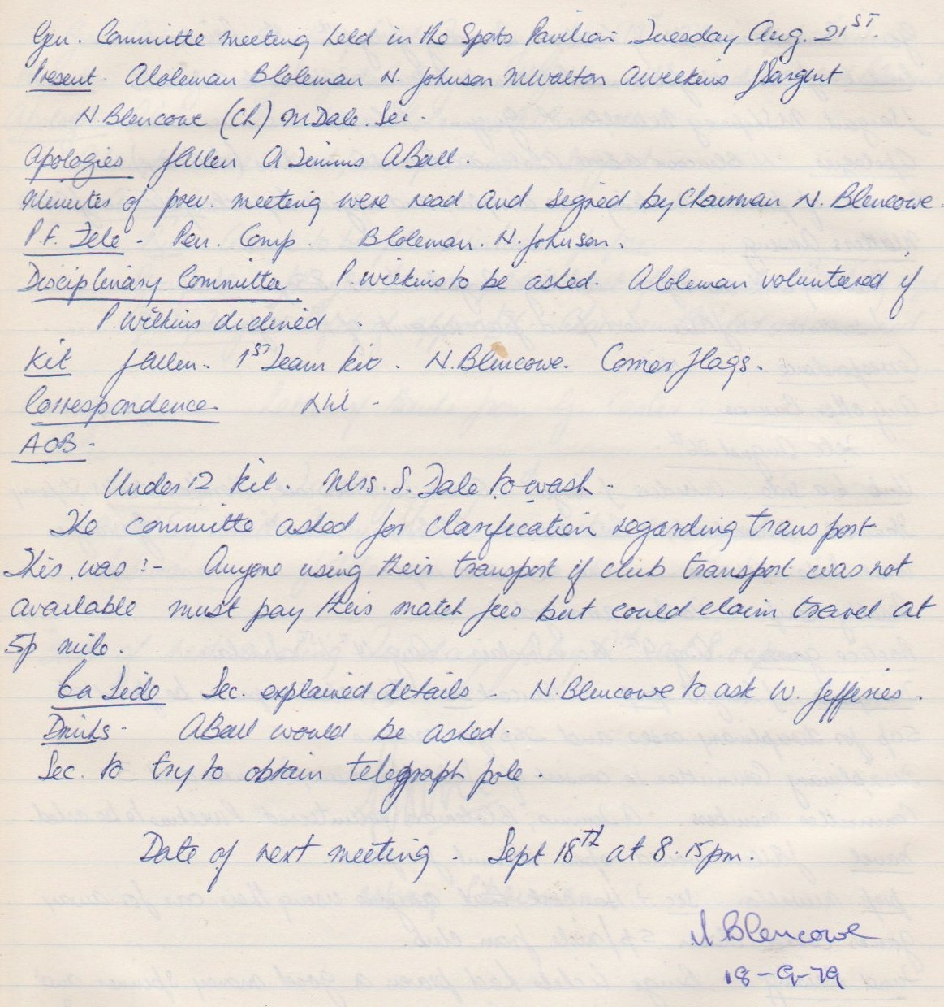

**General Committee Meeting**

**September 18th 1979**

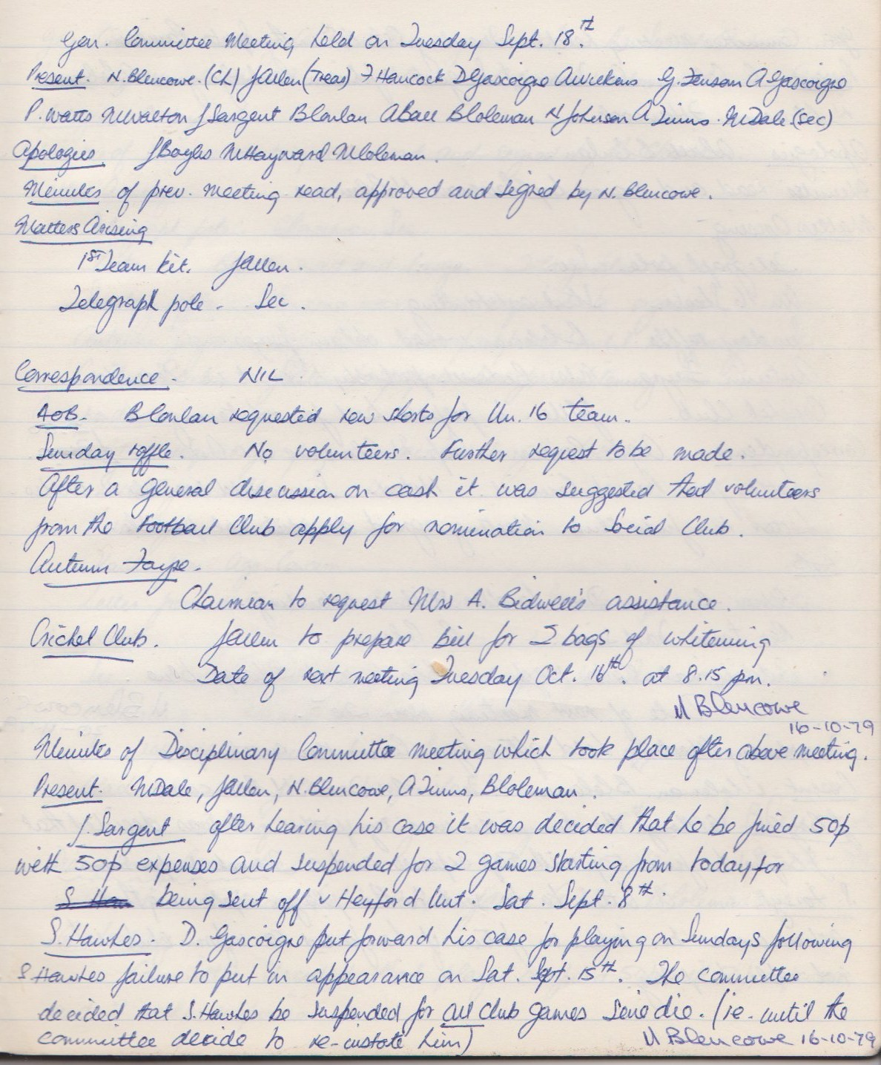

**General Committee Meeting**

**October 16th 1979**

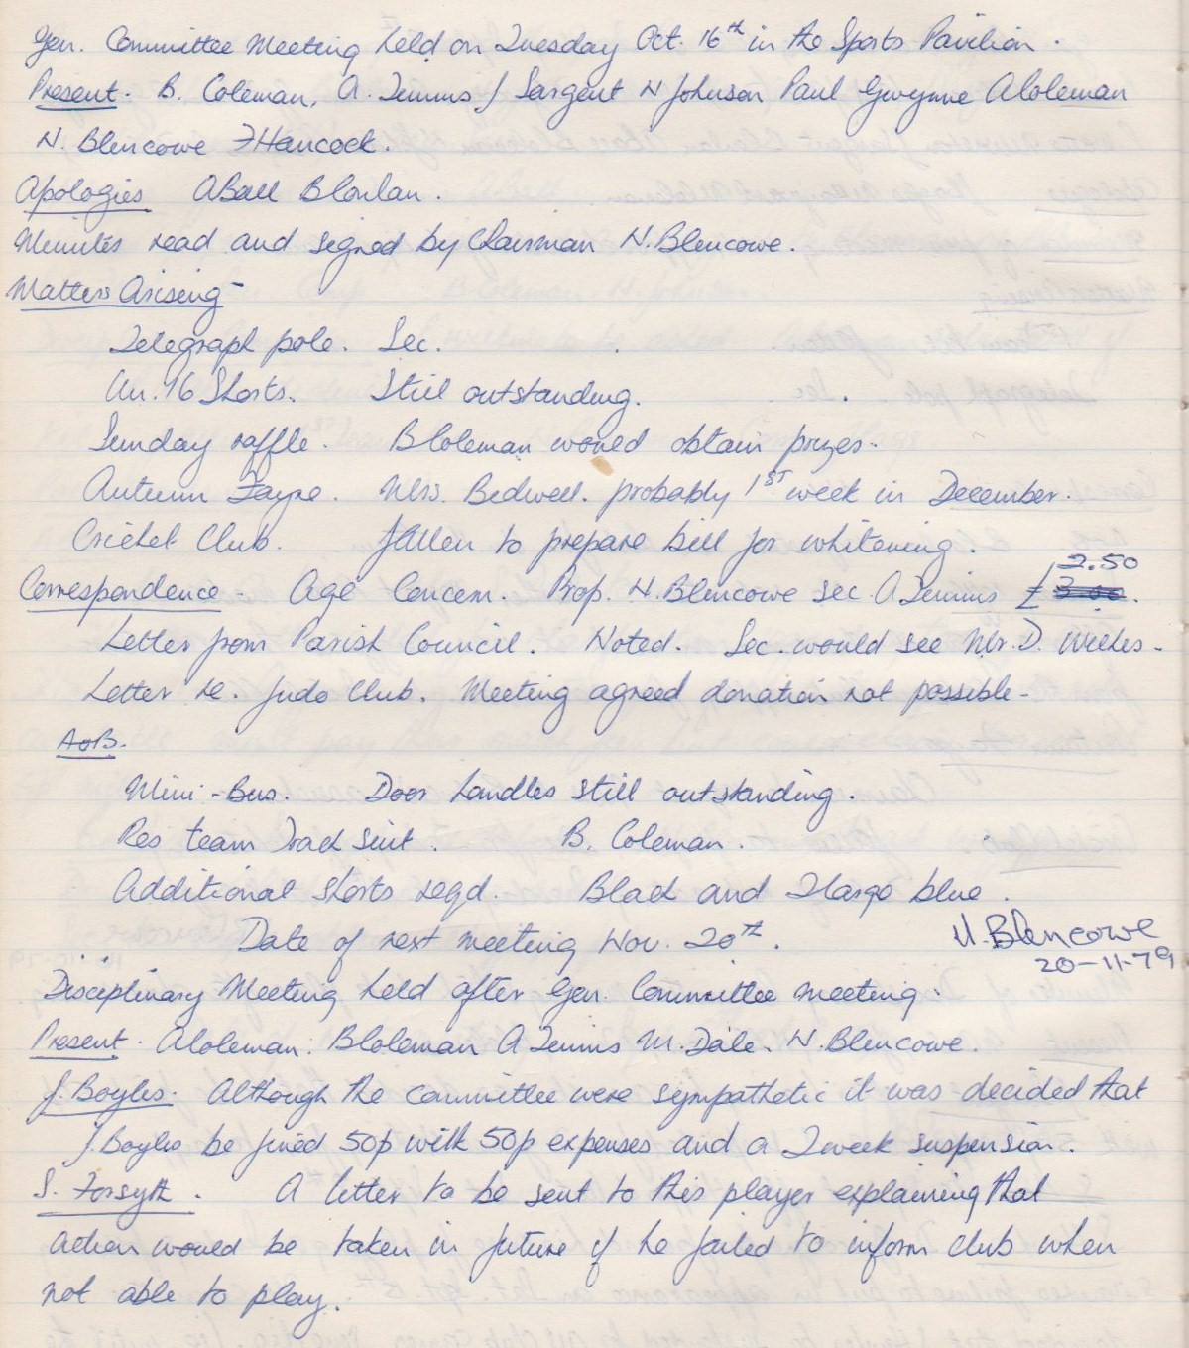

**General Committee Meeting**

**November 20th 1979**

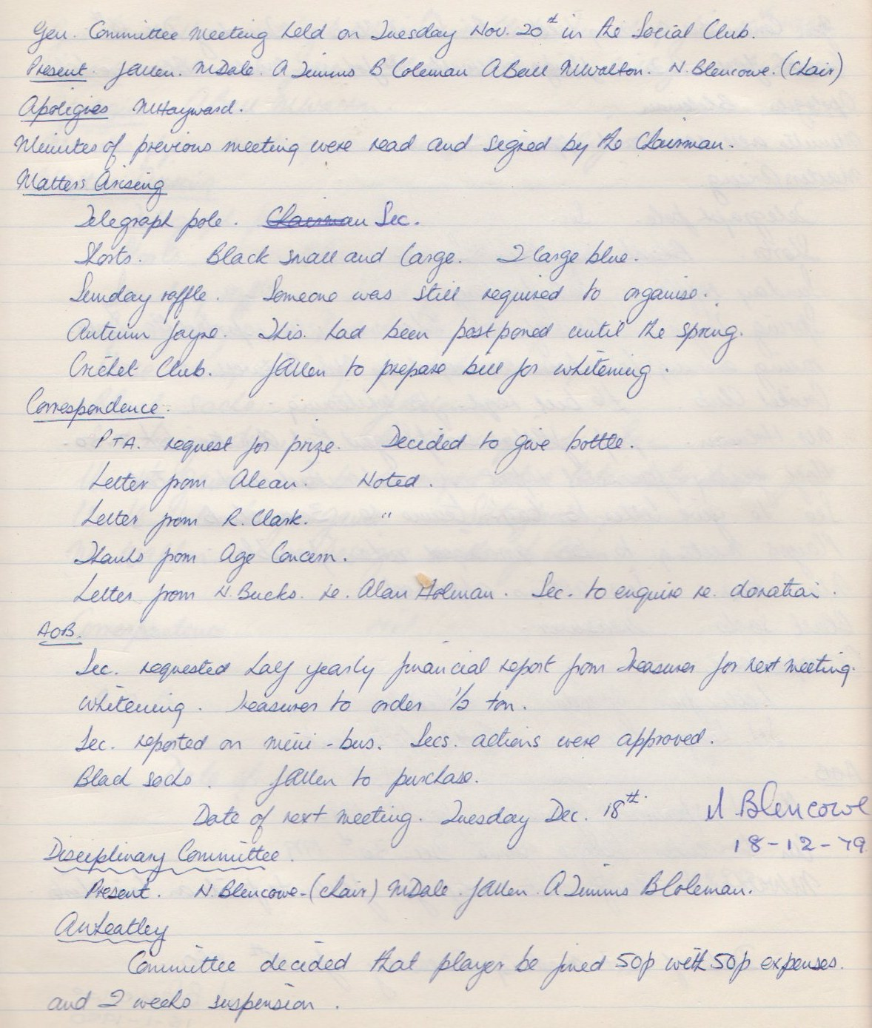

**General Committee Meeting**

**December 18th 1979**

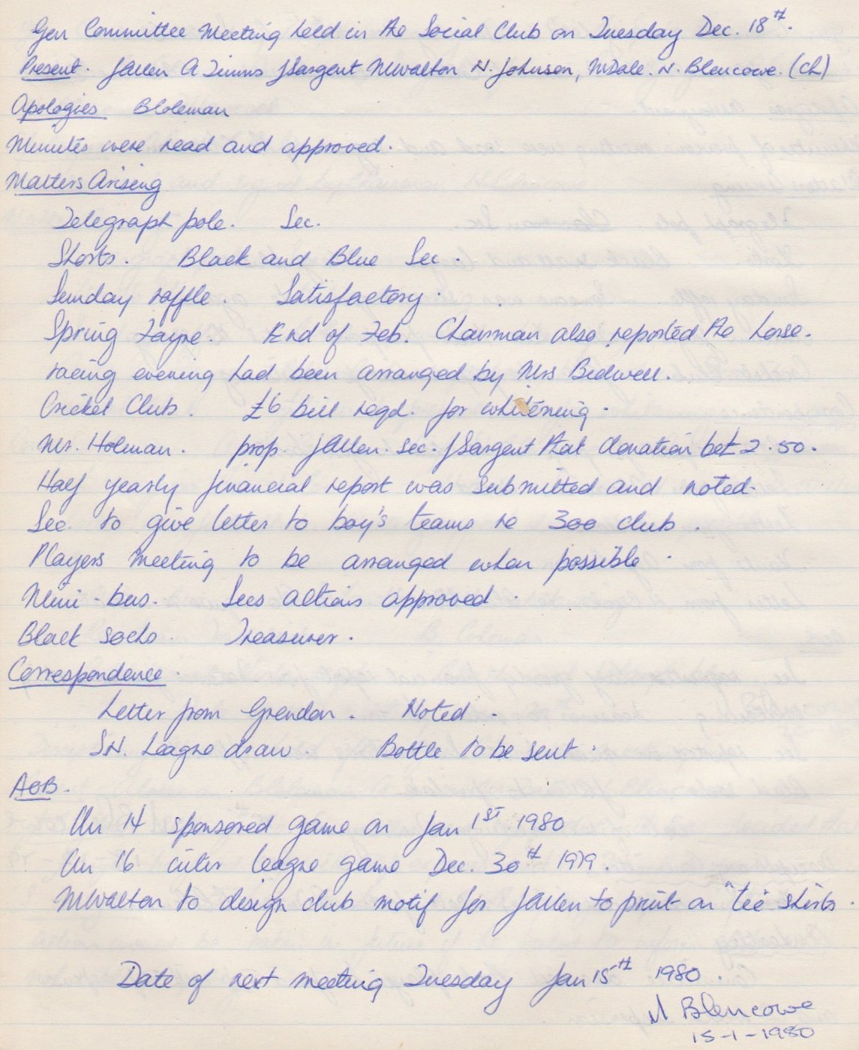

**General Committee Meeting**

**January 15th 1980**

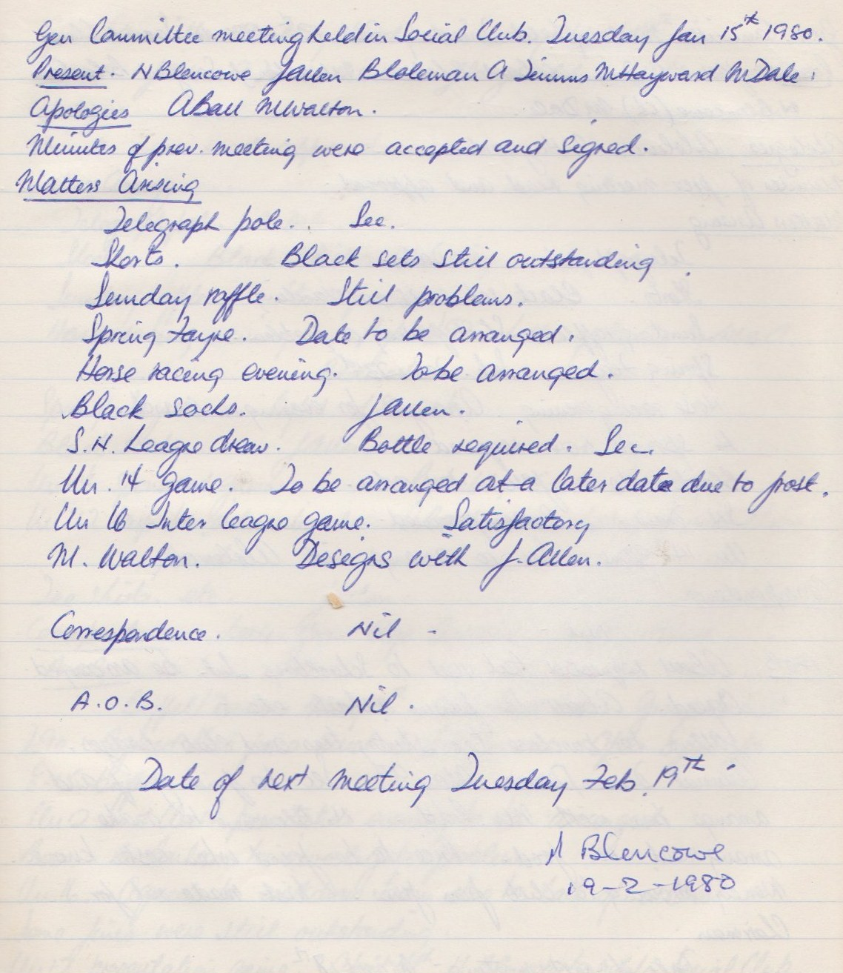

**General Committee Meeting**

**February 19th 1980**

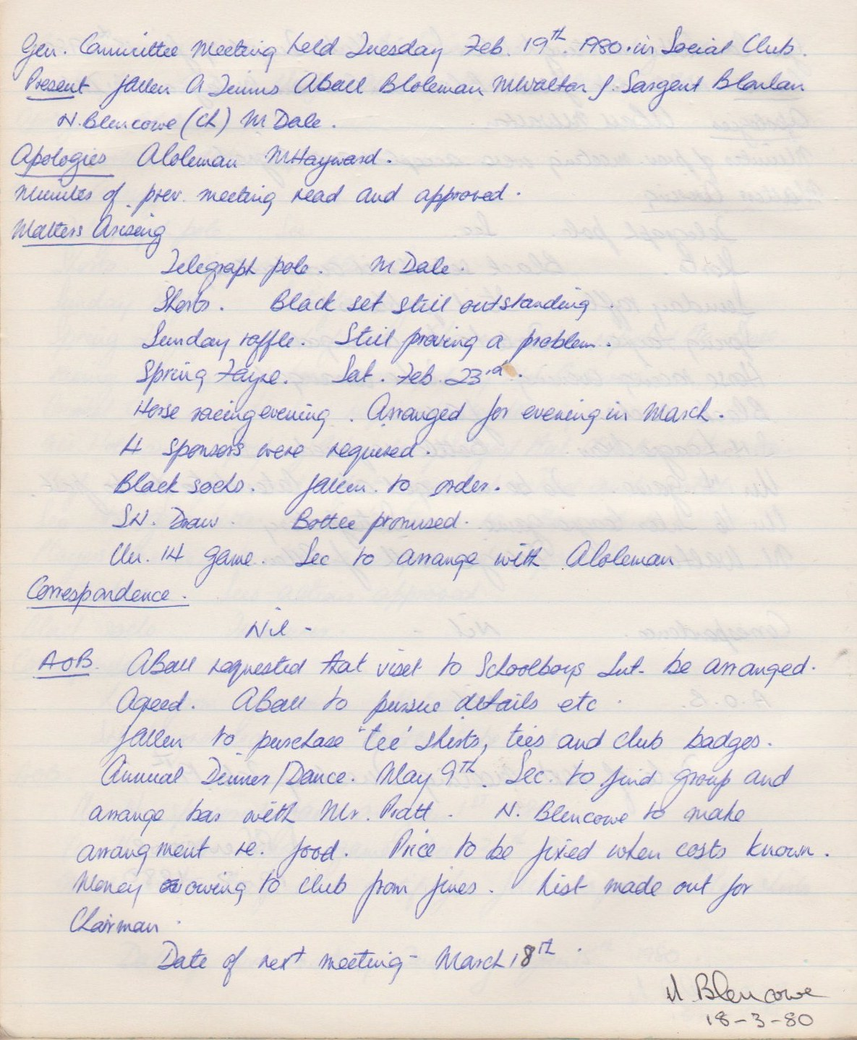

**General Committee Meeting**

**March 18th 1980**

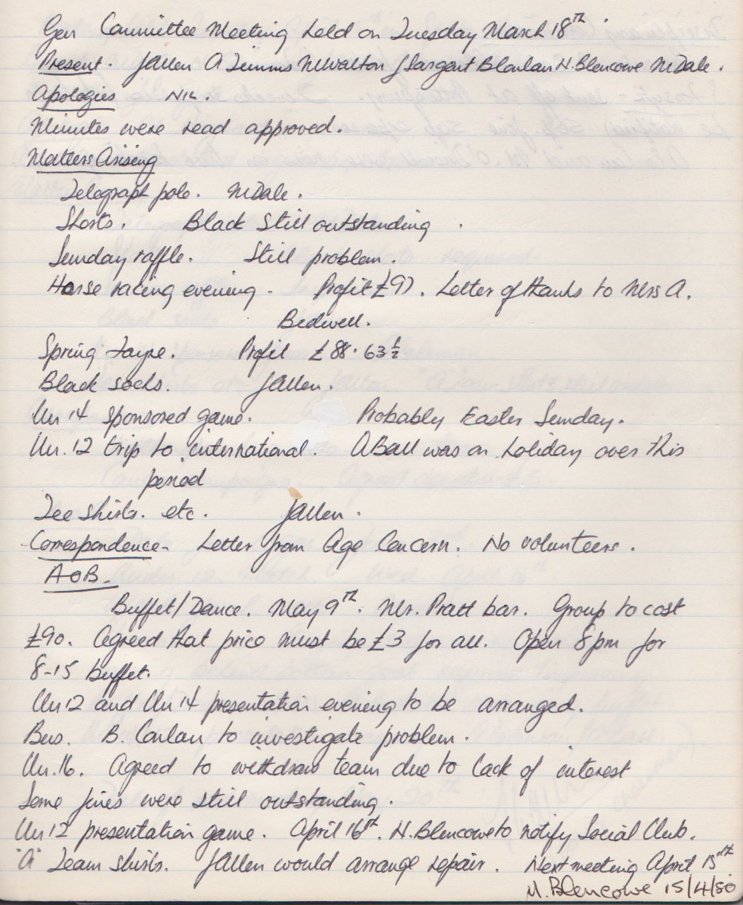

**Disciplinary Committee Meeting**

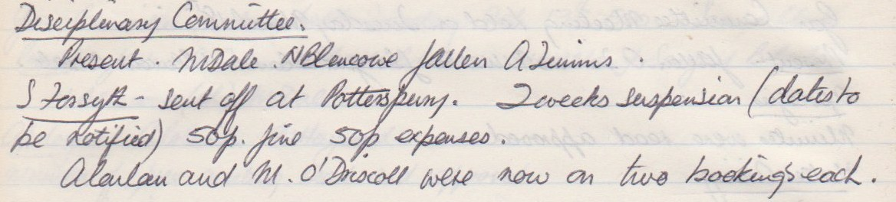

**General Committee Meeting**

**April 15th**

